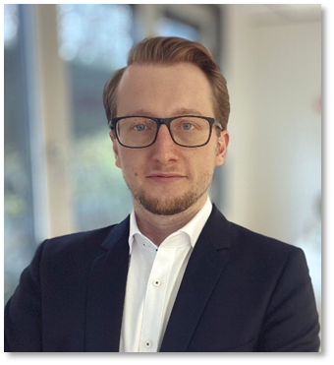

*Fabian Chowanetz  
Director, Automotive Consulting*

*Fabian Chowanetz is a Director in Automotive Consulting at J.D. Power Europe where he supports clients developing competitive advantages by integrating the Voice of the Customer into their strategic planning and product development.*

*Supporting the development of vehicles, components and interaction concepts for manufacturers around the globe, the focus of his work is on improving in-vehicle controls as well as user experience with digital user interfaces and services.*

*Prior to joining J.D. Power in 2016, Mr. Chowanetz worked at a German premium OEM in series development of digital instrument clusters and control elements, gaining interdisciplinary experience on vehicle development processes.*

*Mr. Chowanetz graduated in the field of Human Machine Interaction and holds a Dipl.-Ing. degree in Electrical Engineering from the Technical University of Munich, Germany.*

*He also holds a Certificate in User Experience from Nielsen Norman Group with specialty recognition in the fields of UX Management and UX Research.*